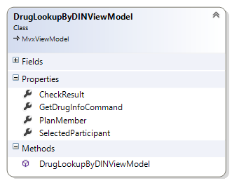

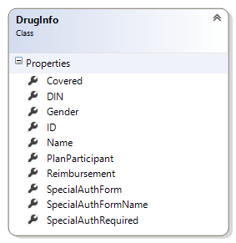

# DrugLookupByDINViewModel

Drives the lookup by name process (pp 8 – 14 GSC Mobile Solution iPad Wireframe).

## Properties

DIN -> the Drug Identification Number

PlanMember -> The planmember (including the list of dependents) currently logged in

SelectedParticipant -> Of the PlanMember, or dependents, the single item selected from the List of potential people

CheckResult -> After the GetDrugInfoCommand has been executed, the detailed result of the inquiry as a DrugInfo object

## Commands

*Reminder* a reference to System.Windows must be set in the References for the ICommand interface to be available. Command bindings will not work without this. This is particularly important to remember when working in iOS projects

GetDrugInfoCommand -> Executes an inquiry to determine the selected Participant’s coverage elegibility for the selected drug.a